**DAILY ONLINE ACTIVITIES SUMMARY**

|  |  |  |  |  |  |  |  |
| --- | --- | --- | --- | --- | --- | --- | --- |
| **Date:** | **31/05/2020** | | | | **Name:** | **Imran Khan** | |
| **Sem & Sec** | **8th A** | | | | **USN:** | **4AL16CS040** | |
| **Online Test Summary** | | | | | | | |
| **Subject** | | **SMS** | | | | | |
| **Max. Marks** | | **60** | | **Score** | | **60** | |
| **Certification Course Summary** | | | | | | | |
| **Course** | **AWS TRAINING** | | | | | | |
| **Certificate Provider** | | | **AWS** | **Duration** | | | **100minutes** |
| **Coding Challenges** | | | | | | | |
| Problem Statement:  Write a C Program to find the leaders in the array. | | | | | | | |
| **Status: Solved** | | | | | | | |
| **Uploaded the report in Github** | | | | **yes** | | | |
| **If yes Repository name** | | | | **Imran040** | | | |
| **Uploaded the report in slack** | | | | **yes** | | | |

**Online Test Details:**

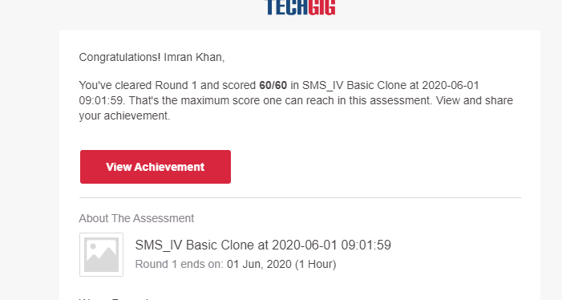

**Certification Course Details**:

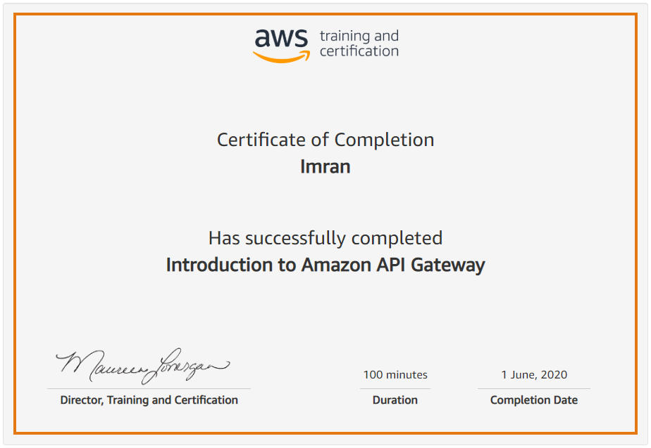

**Coding Challenges Details**:

**program1:**

|  |
| --- |
|  |
| #include<stdio.h> | |
|  | |  |
|  | | void main() |
|  | | { |
|  | | int n, i, j, a[10]; |
|  | | printf("Enter the value of n: "); |
|  | | scanf("%d",&n); |
|  | |  |
|  | | printf("Enter the numbers:\n"); |
|  | | for(i=0;i<n;i++) |
|  | | scanf("%d",&a[i]); |
|  | |  |
|  | | printf("The leaders are\n"); |
|  | | for (int i = 0; i < n; i++) |
|  | | { |
|  | | j = 0; |
|  | | for (j = i+1; j < n; j++) |
|  | | { |
|  | | if (a[i] <= a[j]) |
|  | | break; |
|  | | } |
|  | | if (j == n) |
|  | | printf("%d ",a[i]); |
|  | | } |
|  | | } |